DELIVERABLE 3
CSCE 5430
GROUP 10

Lohith Kumar Velkuri
Vynatheya Reddy Vuppunutula
Kiran Kumar Raju Ganga Raju
Srikanth Reddy Ettem

TABLE OF CONTENTS
- Requirements
  - Homepage with List of Events
  - Selecting an Event
  - Selecting Number of Tickets
  - Booking Tickets
  - Booking Page
  - Confirmation Page
- UML Design
  - Class Diagram
  - Sequence Diagram
  - Use case Diagram
- Test Cases
  - Testing Ticket Booking Feature
  - Testing Cost Calculation
- Breakdown of Team Roles and Responsibilities
- User Manual
- Compiling/Running Program and Test Cases
- Peer Review Feedback
- Changes to Requirements and Development Phases

REQUIREMENTS
The following components/features were developed during this phase:
- Homepage with list of events
- Selecting an event
- Selecting number of tickets
- Booking tickets
- Booking page
- Confirmation page

Homepage with list of events
In this page, the user can view the list of events that are taking place. There are several events listed and the users can browse the different types of events. The events are showcased in the form of widgets. A dynamic view of the events is provided. This component has high priority.

Selecting an event
From the list of available events, the user selects an event. By clicking on the event, the application directs the user to the page of that particular selected event. This component has high priority.

Selecting number of tickets
In the event page, the user can view the information about the event as well as the venue. The user can also view the number of available tickets and select the number of tickets they wish to buy from the textbox. This component has high priority.

Booking tickets
After selecting the number of tickets for the event, the user clicks on the ‘Book Now’ button. If the number of selected tickets exceeds the number of available tickets, then an error message is displayed. Otherwise, the user’s request is accepted and the user will then be directed to the booking page. When this step is completed, the number of available tickets for the event is automatically deducted. This component has high priority.

Booking page
In this page, the users can view and finalize the tickets they added for a particular event. If necessary, they can make any changes to their booking by editing the number of tickets, type of tickets or selecting a different time for the event, etc. If everything is as desired, then the user may proceed to enter their details such as payment information, etc. After this is completed, the user would be directed to the confirmation page. If the user decides not to proceed and cancel their booking, the selected tickets are then automatically sent back to the available tickets for the event. This component has high priority.

Confirmation page
This is the final page. In this page, the tickets that the user purchased are generated and confirmation is given to the user. A unique code is generated for each purchase. This code would allow the user access or entry to the event. This component has high priority.

2. UML DESIGN

Class Diagram

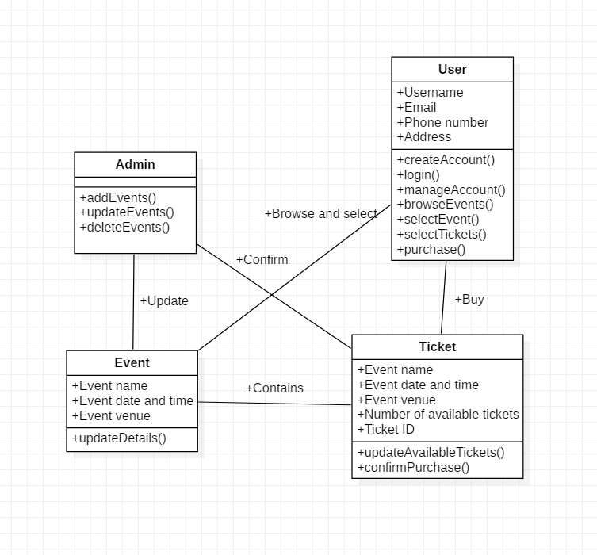Figure 2.1.1. Class Diagram

Sequence Diagram

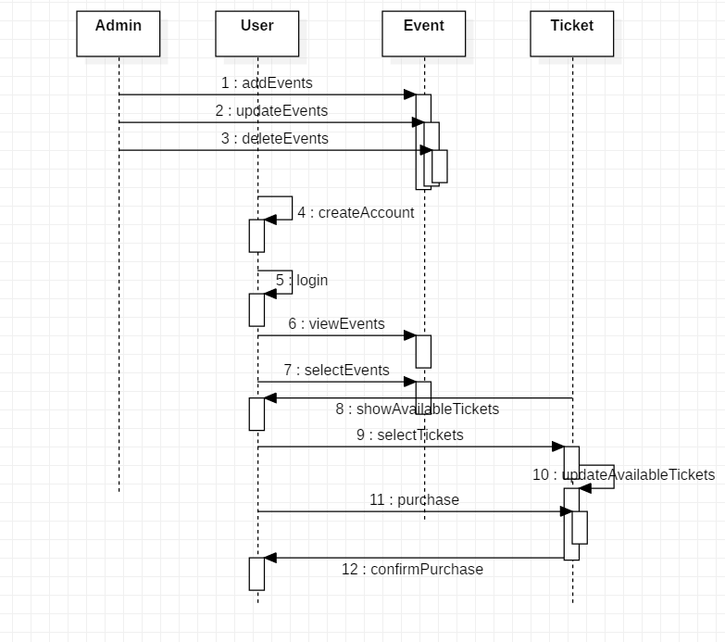
Figure 2.2.1. Sequence Diagram

Use Case Diagram

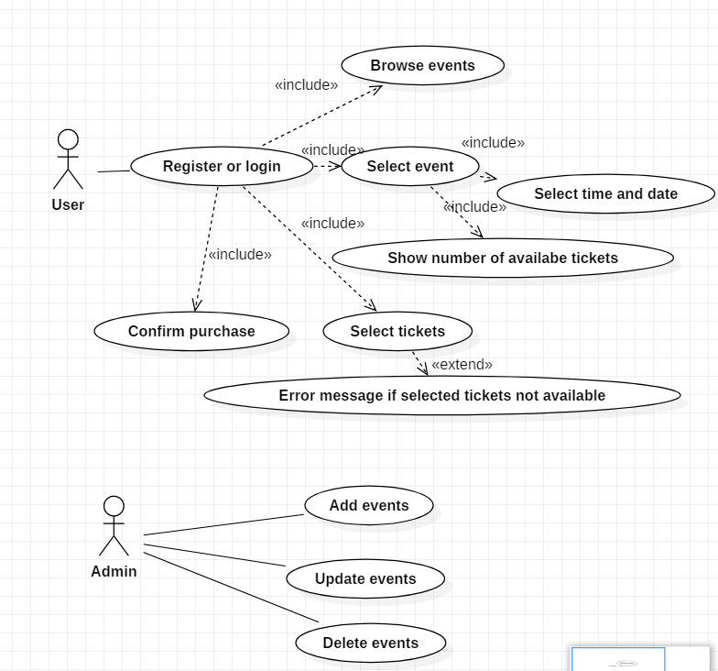
Figure 2.3.1. Use Case Diagram

TEST CASES

Testing Ticket Booking Feature
Description: This case tests for the correctness in booking the required tickets out of available tickets. This means a user should not be allowed to book more than the available tickets.
Input: The number of tickets the user is requesting to book. ( 1 to 100 – valid input)
Output: True, if the requested tickets is less than available or False, otherwise
Unit Test Code:
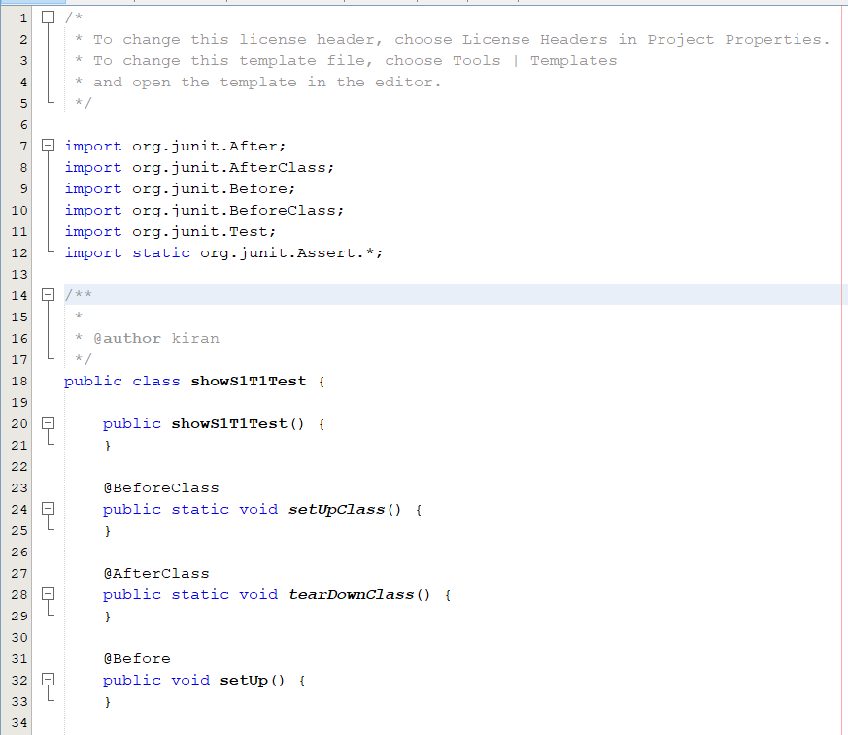
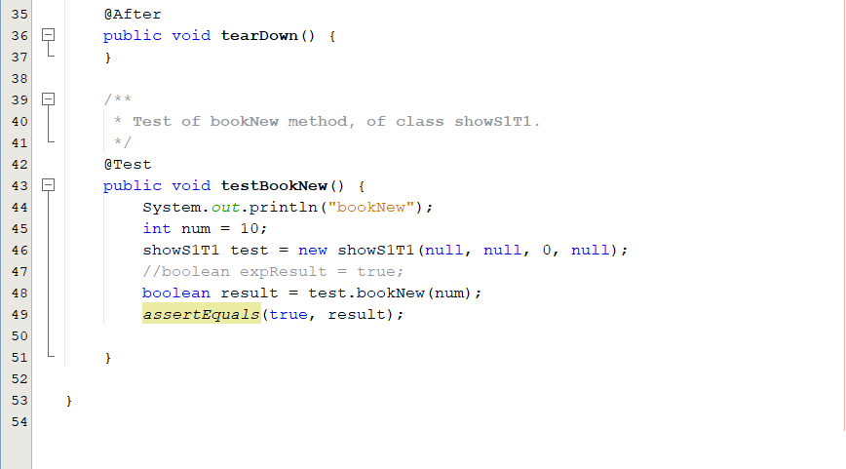

Positive case : (Input is in range i.e., 1 to 100)
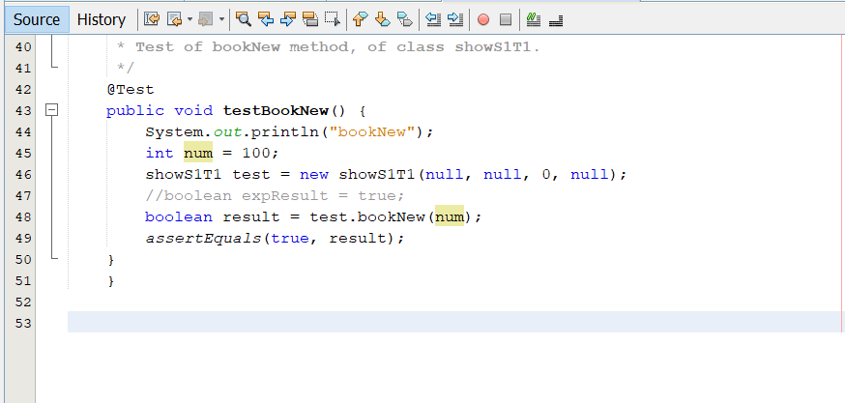

Result:
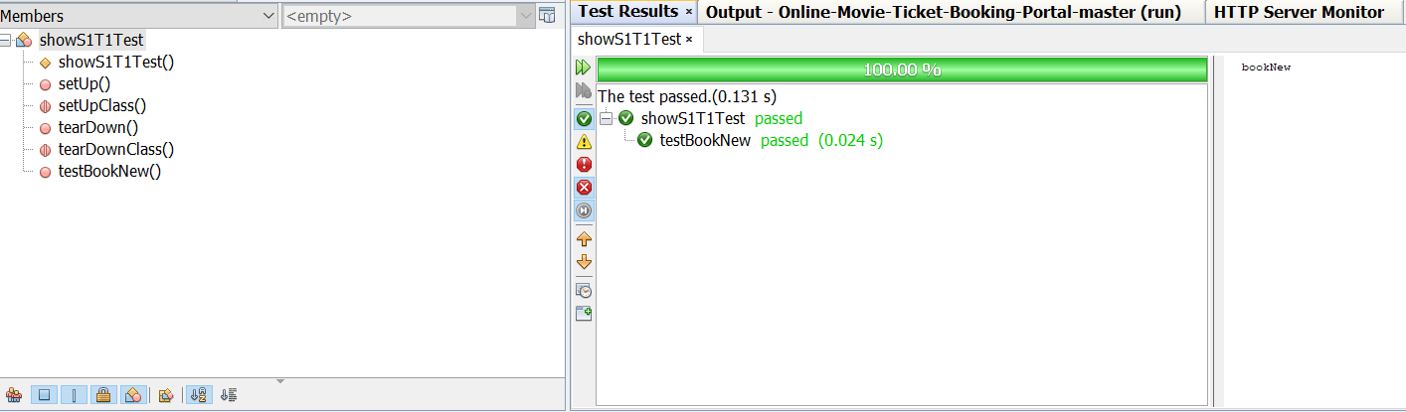

Negative case : (Input is a negative integer)
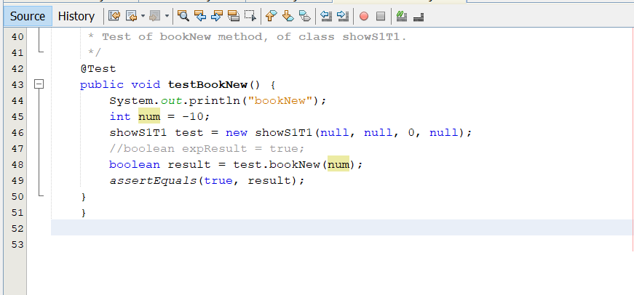
Result:
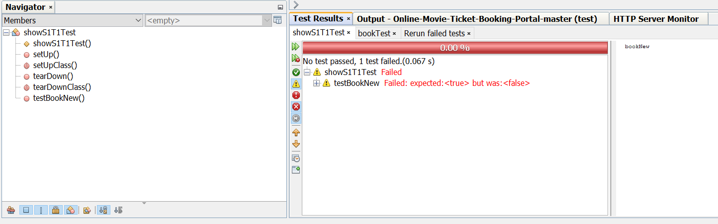

Out of Bounds case: (Input is greater than 100)
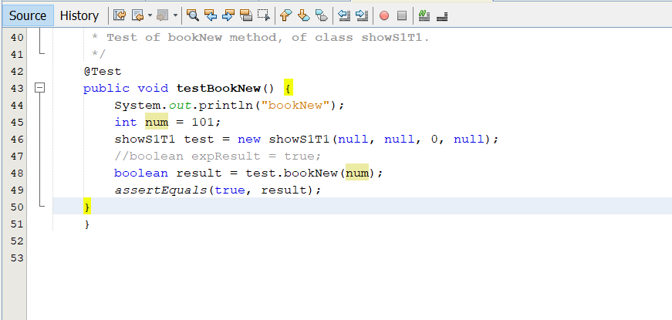
Result:
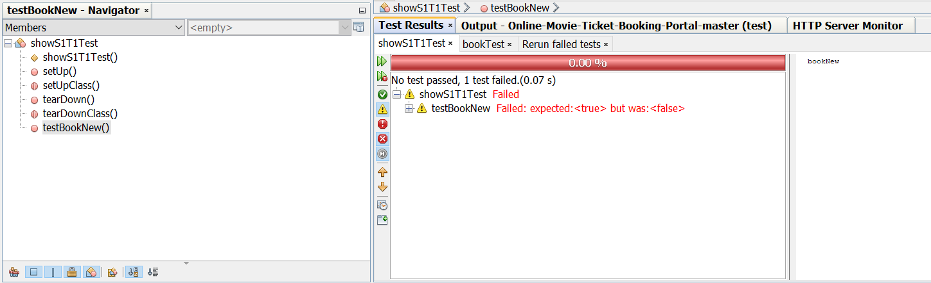

Testing Cost Calculation
Description: This case tests if the program is calculating the cost correctly based on the user selected class value (i.e., silver or gold or platinum).
Input: String with class value (silver or gold or platinum)
Output: cost of the ticket in integer form
Unit Test Code:

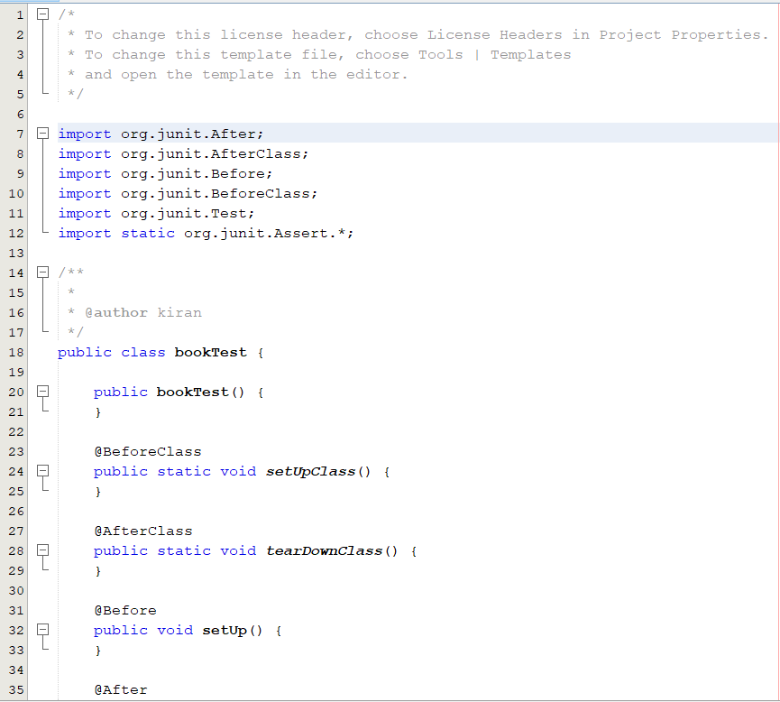
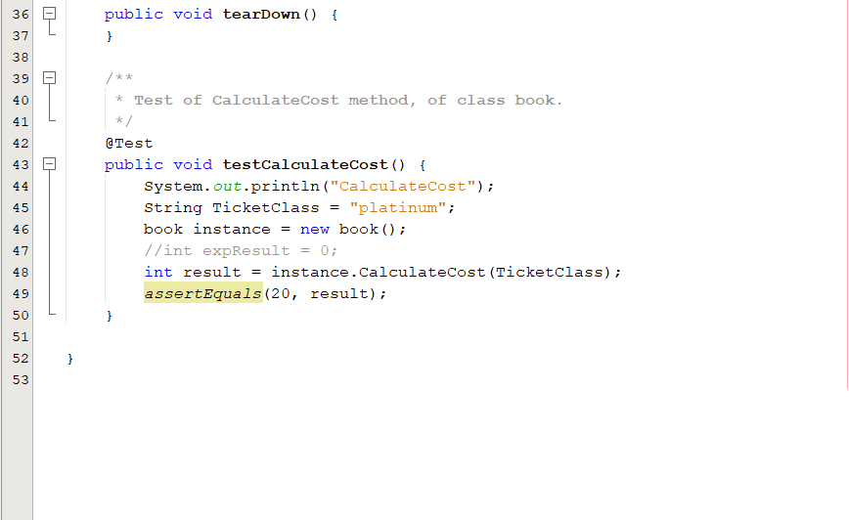

Positive case: (Input is either silver or gold or platinum)
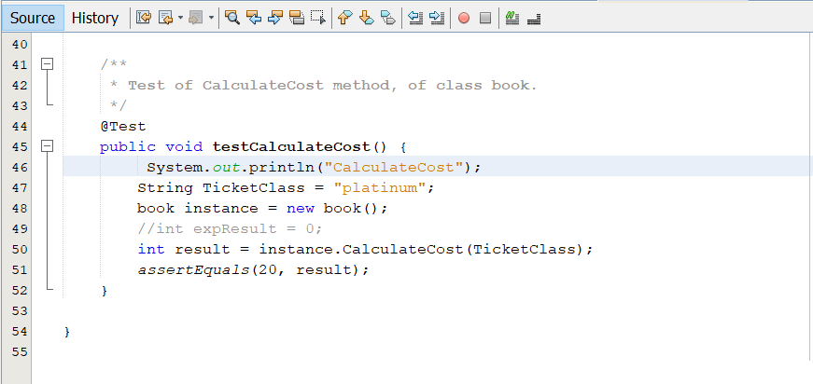

Result:
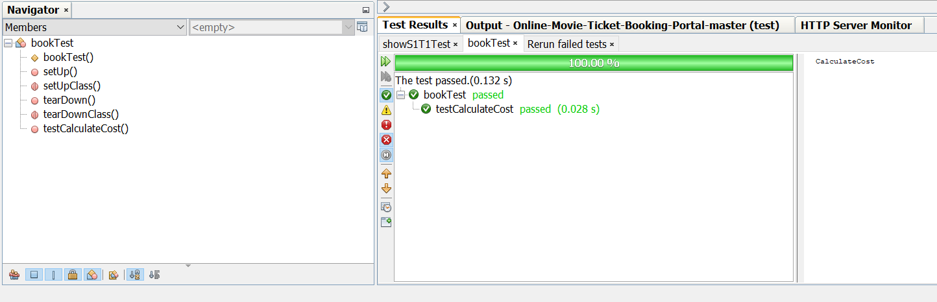

Out of Bounds case: (input is any string other than silver or gold or platinum)
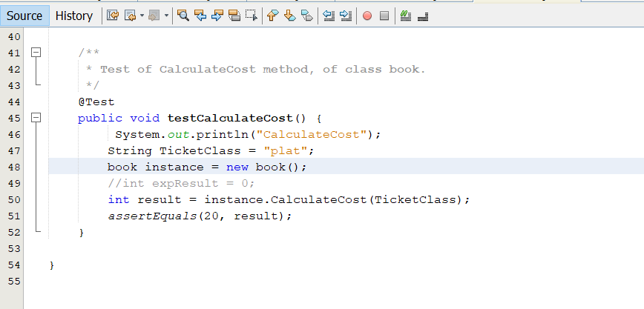
Result:
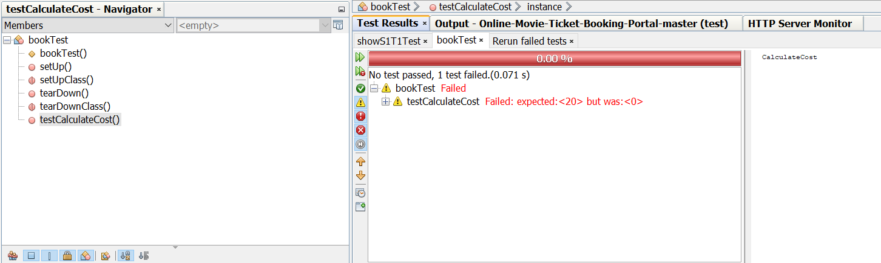

BREAKDOWN OF TEAM ROLES AND RESPONSIBILITIES
- Lohith Kumar Velkuri: Worked on Home page functionality
Main files : home.jsp
- Vynatheya Reddy Vuppunutula: Worked on booking functionality which allows user to book tickets.
Main files: book.java
- Srikanth Reddy Ettem: Worked on database creation and design. Primarily created the database, tables, data dumping and JDBC connection with code.
Main files: MoviePortal.sql
- Kiran Kumar Raju Ganga Raju: Test case design and unit test case creation with test case execution. Worked on home page improve the UI
Main files: showS1T1Test.java, home.jsp, bookTest.java

USER MANUAL
In order to user our program, initially, the end-user needs to install a few softwares on their local computer.
Firstly, our application is developed using Java, which is an object-oriented programming language. We used the latest version of Java, which is Java 1.8, or Java 8. The end-user has to download the software. This can be done using the following URL:
https://www.oracle.com/technetwork/java/javase/downloads/jre8-downloads-2133155.html

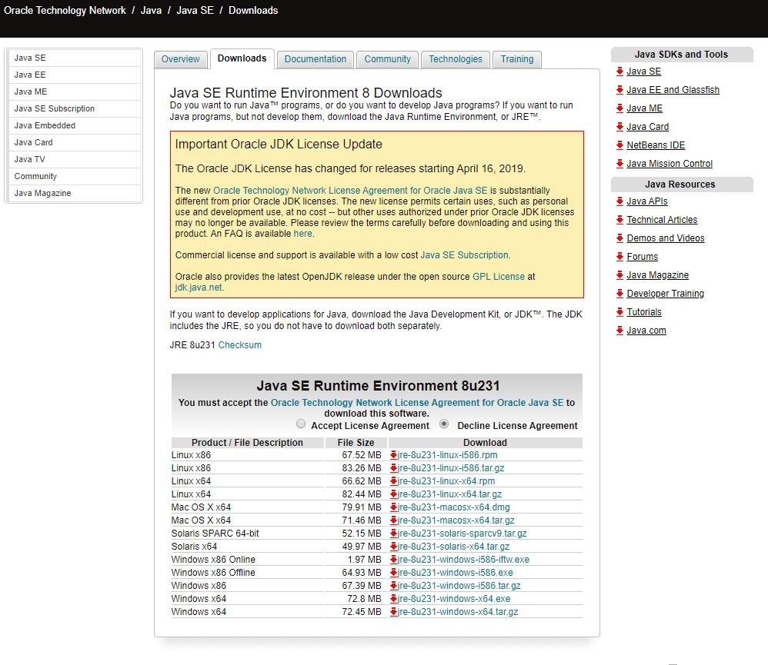
Depending upon your operating system and the bit size (32 bit or 64 bit), you need to select and download the software.
Once you install the software, you need to set class path in your computer. You need to go to Control Panel->Environment Variables->Class Path
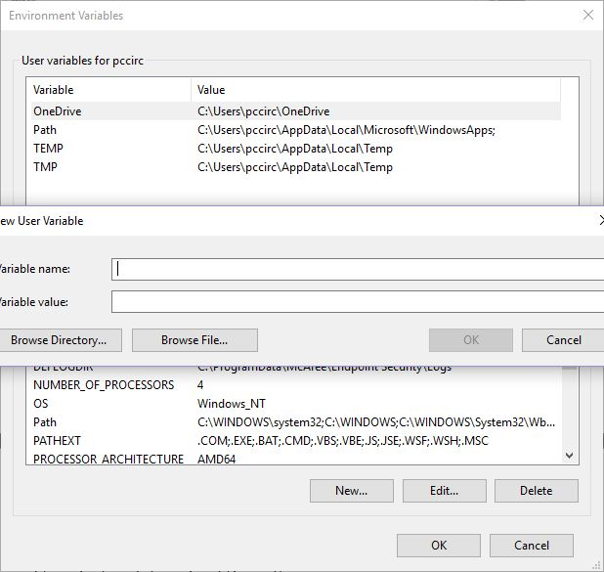

You need to enter the JDK and JRE class paths over here. Next, you need to open command prompt and type Java and Javac to check whether the installation was done properly or not.
Secondly, we need a database for every enterprise application to store repository of data. We have been suing MYSQL Server 5.5 database for our application. We can download that using the following URL:

https://dev.mysql.com/downloads/mysql/5.5.html

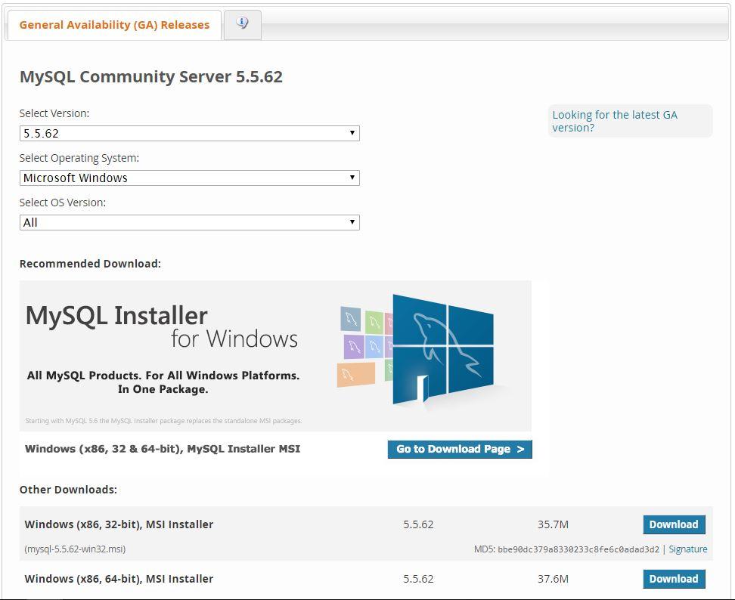

Once you are done with the installation, you need to open movieportal.sql file. This file contains the database commands, etc.
We had created Database UserDB.
We had created table structure for Users using CREATE command.
CREATE TABLE TABLENAME (Variable1 Type1, Variable2 type2, );
We had also created tables for Shows and movie database using the same CREATE command.
Next, we had dumped data into these tables by inserting data into it using INSERT command,
INSERT INTO table name (column1, column2, column3,)
VALUES (value1, value2, value3,);

Once we are done with the installation of Java and MYSQL server, we need to install an IDE.
We are using Net beans IDE in order to execute our open project. We can install it by using the URL:
https://netbeans.org/downloads/8.2/
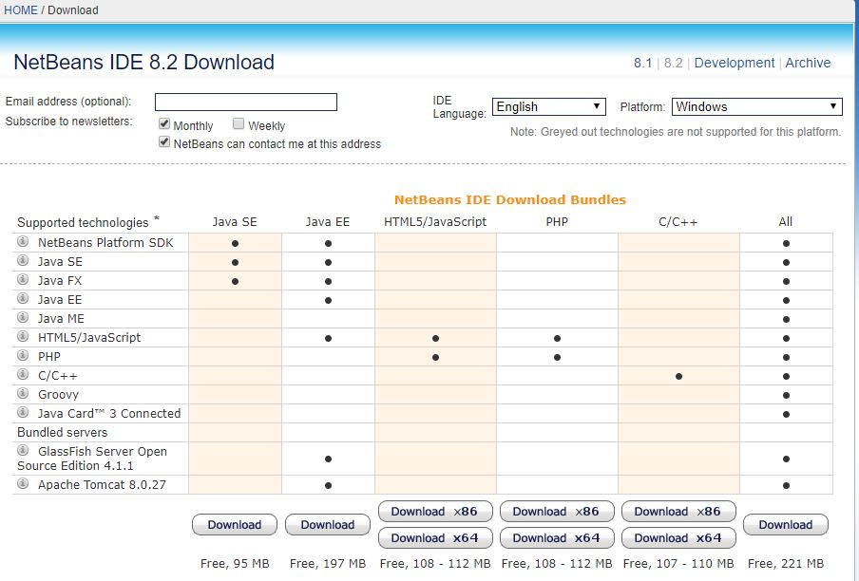

Net Beans IDE helps you execute your web application easily since it has in-built servers, provides clear overview of enterprise applications and it provides different perceptions of our data.
Along with these softwares, we have been using JDBC (Java database connectivity) in order to maintain communication between the database and the server. We have been using JDBC type 4 driver for establishing the connection.
Once you have downloaded all the softwares and while executing the application on your local machine, if the end user encounters any error, then he/she needs to delete the current JDBC driver and needs to install it again.

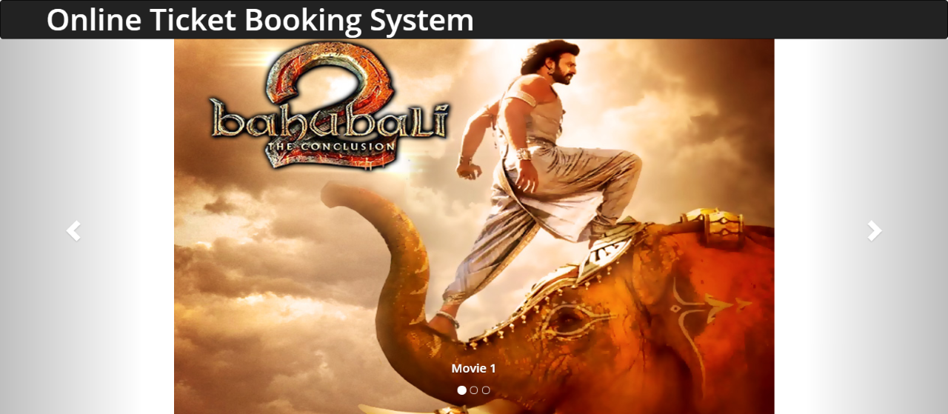

The homepage for our web application mainly deals with booking movie tickets.as soon as the customer opens the web application, he/she will be able to view the list of movies that are available to book the tickets.
First, the customer has to select a particular movie from the pool. He/she will be able to view the details about the movie like show timings, duration, screen number, number of tickets available.

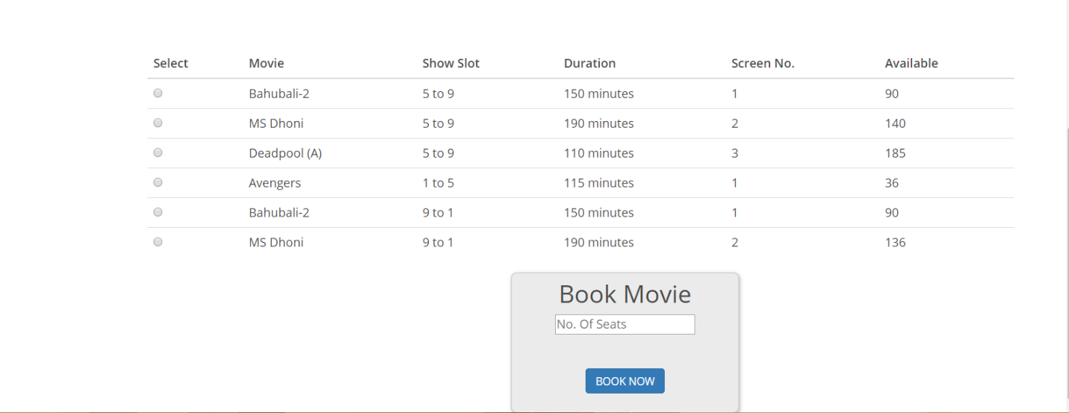

Once the customer had decided to select a movie, he/she has to select the number of tickets. Usually the number of tickets ranges from zero to number of tickets available at that moment.
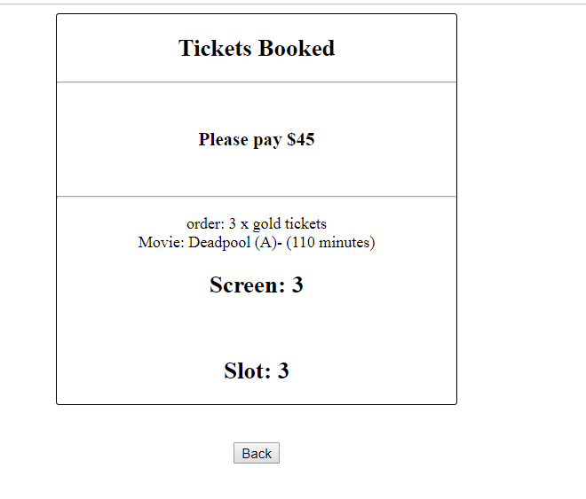

There tickets are classified into three categories:
Silver: 10$
Gold: 15$
Platinum20$:
Once you are done with selecting the number of tickets, you need to click on Book Now button.
You will be redirected to the next page .Here, you will be able to view the summary of the ticket and the amount that they need to pay.

COMPILING/RUNNING THE PROGRAM AND TEST CASES
Running the test cases:
To run the test cases,
1. Right click on the test file
2. Click on run test. This will run the existing test cases automatically with the values provided manually in each test case.

Executing the code:
1. Open the project in Netbeans (We opted this as it has In-built server)
2. Right click on main project file
3. Click on clean and build
4. Now once the build is succeeded, click on run
5. This will start the server and will try to open it in the default browser set in the Netbeans
6. If the browser does not open, copy the url from the run section and try to load the page.
7. If facing any errors related to JDBC driver connection, we need to remove the JDBC driver from Libraries folder in Netbeans and try to add the driver again. Now, without running the project again, reload the browser.

PEER REVIEW FEEDBACK
It was brought to our attention from our peers that some of the functionalities in our Deliverable 2 were not written in a clear manner. In this deliverable, we have ensured that our requirements were listed and detailed more precisely without room for any ambiguity or misinterpretation.
It was also suggested that we include a return policy for cancelled tickets or events. However, that functionality is out of scope for our project.

CHANGES TO REQUIREMENTS AND DEVELOPMENT PHASES
Some requirements have been modified. Also, some of the components that were planned for Phase 2 are being implemented in Phase 1 and some of the components planned for Phase 1 are being implemented in the next phases. They are:
- Event information page and browse events page have been integrated into one single page, which is the homepage.
- Login/Register page is not being implemented in this phase. We decided that since this is a relatively simple component to implement, this could be postponed for further phases. Instead, we decided to focus on other functionalities with high priority that are the heart of the project.
- Event selection page and ticket selection page are being implanted in Phase 1 itself as these are critical parts of the project.

